1. 下载linux版Pycharm

下载地址：<http://www.jetbrains.com/pycharm/download/>

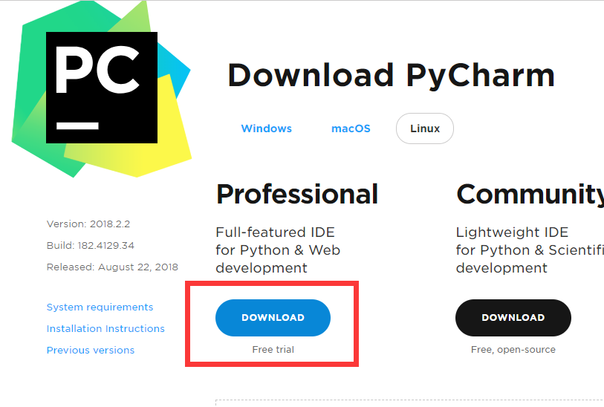

1. cd ~/Downloads
2. 解压下载过来的压缩包 tar -xvzf pycharm-professional-2018.2.2.tar.gz -C ~
3. cd ~
4. cd pycharm-community-2017.2.3/bin
5. sh pycharm.sh
6. PyCharm运行OK,自行配置解释器路径即可!